**CHAPTER-1: INTRODUCTION**

**Introduction to internship:**

Internship is an on-the-job training programme offered to students to balance the gap between class room theories and industry expectations. It is an on-field training programme, which may last from 2 weeks to 1 month period. During the internship period, the candidate may be paid or not paid with monetary benefits for the services rendered by him, but definitely compensated with work experience and real-life learning that benefits his career in the long run.

An internship is a training opportunity which is provided to students, such as graduates or post-graduates, to seek and feel the actual work experience and corporate culture before they enter any sector as working professionals. Internship programme is one of the types of on-job training programme, were the student gets a chance to experience the working environment, gets trained to the practical work exposure, sees implementation of class room theories in the work field and identifying the difference, coming with an appropriate opinion to overcome such gaps which indirectly benefits the university or college to know the actual requirements of industry, and making necessary changes in academics according to the industry needs so that students benefit with better outcomes.

Internship is a great opportunity even to employers to recognise the talents in the market, as in the competitive environment and high rate of unemployment, finding a right person for a right job has become a difficult task. This indirectly makes internship programme effective as the employer can see a candidate’s potential and dedication towards his work and his skills, strengths, weakness, etc.., throughout the internship period. An employer can encourage the right and eligible candidates with pre-placement offer which will help his organisation to hire a suitable candidate who can contribute to the organisation well.

1. **Objectives of internship:**

* To get an idea about organisation working structure.
* To gain knowledge about different departments in an organisation and their functioning.
* To understand corporate culture and environment.
* To identify various decision-taking levels in an organisational structure.
* To implement class room learning practically and observing the gap.

**2. Reasons for doing internship:**

* To get real-life experience and exposure towards corporate workings.
* It’s an opportunity to assess our strengths and weakness.
* Helps connect with professional people and opens door to corporate network.
* Gives an opportunity to prove our self in performance.
* Acts as a transformational tool to student to become employee

**CHAPTER – 02**

**COMPANY PROFILE**

Company is working as a Chartered Accountants firm under the rules and regulations and code of ethics designed for CA firms ICAI ( The Institute of Chartered Accountants of India )

The institute of Chartered Accountants of India (ICAI or the Institute) was established as statutory body on January 1,2015 under Chartered Accountants Ordinance,2015 to regular the profession of accountancy in the country.

ICAI is a governed by the council which consists of nineteen members. Fifteen members are elected from amongst the members for a period of four years. The remaining four of the Council members are nominated by the government of India.

**Vision of the ICAI :**

The profession of Chartered Accountants in India should be the benchmark of professional excellence upholding the principles of integrity transparency and accountability.

**Mission of ICAI :**

Is to achieve excellence in professional competence, add value to businesses and economy, safeguard public interest; ensure ethical practices and good corporate governance while recognizing the needs of globalization.

These kinds of firms provide different kinds of professional services like audit, taxation and management consultancy to its clients.

**SRINATH L &Co.** was established in the year 2015. It is a leading chartered.

Accountancy firm rendering comprehensive professional services which include audit, management consultancy, tax consultancy, accounting services, manpower management, secretarial services etc.

Srinath L & Co is a professionally managed firm. The team consists of distinguished chartered accountants, corporate financial advisor and tax consultants. The firm represents a combination of specialized skills, which are geared to offers sound financial advice and personalized proactive service .Those associated with the firm have regular interaction wit

industry and other professionals which enables the firm to keep place with contemporary developments and to meet the needs of its clients.

**CORPORATE SERVICES**

* Incorporation of company
* Consultancy on company Law matters.
* Planning of Mergers, Acquisitions, De-mergers ,and Corporate re-organizations.
* Filing of annual returns and various forms, documents.
* Clause 49 review for compliance with fiscal, corporate and tax laws
* Secretarial matters including share transfers
* Maintenance of Statutory records
* Consultancy on public/rights/Bonus Issue of shares.

**AUDIT**

**Broadly, Audit involves the following:**

* In- depth study of existing systems, procedures and controls for proper understanding. Suggestions for improvement and strengthening.
* Ensuring compliance with policies, procedures and statutes.
* Comprehensive review to ensure that the accounts are prepared in accordance with Generally Accepted Accounting Policies and applicable Accounting Standards/IFRS.
* Reporting inefficiencies at any operational level.
* Checking the genuineness of the expenses booked in accounts.
* Detection and prevention of leakages of income and suggesting corrective measures to prevent recurrence.
* Certification of the books of account being in agreement with the balance sheet and profit and Loss Accounts.
* Issue of Audit Reports under various laws.

**Types of Audits conducted**

* Statutory Audit of companies
* Tax Audit under Section 44AB of the Income tax Act, 1961.
* Audit under other sections of the Income Tax Act, 1961 such as 80HHC, 80-IA, etc.
* Concurrent Audits.
* Revenue Audit of Banks.
* Branch Audits of Banks.
* Audit of PF Trusts, Charitable Trusts, Schools, etc.
* Audit of Co-operative Societies.
* Information System Audit
* Internal Audits.

A hierarchy is an arrangement of items (objects, names, values, categories, etc.) in which the items are represented as being “above,” “below,” or” at the same level as” one another and with only one “neighbour”above and below each level. These classifications are made with regard to rank, importance, seniority, power status, or authority. A hierarchy of power is called a power structure.

* Partners
* Directors
* Senior Managers
* Managers
* Supervisors
* Senior Trainee Students
* Junior Trainees

Partners are often the founders of the firm. Most of the firms’s names are associated with the names of the partners. They are basically the main parties who issued and sign any report (specifically audit report) on behalf of the firm. Partners mostly communicate with the Senior Managers. In other words, the progress of any report and any inquiry is made from the Senior managers and hierarchal structure is strictly followed to avoid any disruptions.

Managers are inquired of by Senior Managers and mostly manager manage audit field works etc and after field work managers with cooperation of senior managers makes and finalize any audit report to be issued. Senior Manager is a qualified Chartered accountant having more than 10 year working experience.

Field work and information collection and implementation of policies by adopting changes in rules and regulations in the main responsibility of supervisors and trainees. They use different kind of techniques for error and fraud detection.

Srinath L &Co. Is having its head office in Malleshwaram .Almost all the controls and regulations are dealt at head office in Malleshwaram . All the offices constitute different number of departments who basically handle their respective functions. The major departments include:

**Audit and Assurance Department :**

Firm provides audit and assurance services to wide range of clients which include performing audits of financial statements of limited companies, NGOs

and partnerships. Firm also performs special assignments which include management audit, internal audits and investigations. Audit focuses on business issues and the matters that can impact on the financial statements, whilst also retaining the basic audit procedures that test the information contained in the financial statements. Services are aimed to comply with the legal requirements as defined under the various laws and regulations . In doing so firm not only identify the non-compliances but also assists clients in its rectification, designing remedial measures and provides guidance to adhere with the laws and regulations. Firm always endeavour to meet reporting deadlines as set out by the laws and regulations or as mutually agreed with clients, without compromising the profession , legal and ethical requirements.

Firm emphasis on delivering high quality services to clients, adding value to their business through identification of existing and potential control risks and suggesting best possible measures in the given circumstances. Firm always place priority in deploying audit teams to clients who are well equipped with the specific industry knowledge, experience and are professionally sound.

**Tax & Corporate Department :**

Firm delivers taxation services to clients and assists them in obtaining optimal tax benefits available under the laws. Firm also assist clients to comply with the tax rules and regulations and always keep them updated with the latest developments and amendments. Tax personnel are qualified professionals, experienced and knowledgeable. We maintain a comprehensive tax library which always provides ready references and timely solution in complex situations. Firm provides a comprehensive range of tax services which includes;

* Preparation and submission of annual tax returns
* Compliance services
* Tax advisory services
* Representation and litigation with tax authorities
* Personal income tax services

In Srinath L & Co. same staff is handling with tax matters as well as corporate sector. While in corporate firm provides different kinds of services relating to corporate sector from incorporation to winding up of a company.

**Computer Department :**

Departments handles the computer related matters and assists other departments in working properly and efficiently. Department deals with online filing of returns of income for tax departments and finalize audit reports in proper format in a presentable manner. It deals with networking of computers in office and all other problems which may be faced by computer users time to time.

**Correspondence Department :**

It handles with all the correspondence of the firm by sending the solicited and unsolicited information from time to time. Effectively and efficiently manage the day-to-day operations of the Correspondence. Interact with clients to resolve policy and customer issues. Identify trends and remove obstacles in Statement production and delivery by properly maintaining record of all communication for future reference.

This department is mainly concerned with the recruitment, hiring/firing of the firm and this department presents the timely reports on effective utilization of the resources by the firm. A purpose of the human resource is to keep the trained employees and recruit new energetic staff to work. Another purpose of this department is to provide a good working environment for staff and try to make by facilitating them and arranging some recreational activities for them. HR knows the real worth of its employees so cares for them and motivate them to work efficiently and diligently.

The hierarchy adopted by Srinath L & Co, is in accordance with the legal structure a CA firm shall have. Although the ICAI rules permit of not having the supervisors and does not make it mandatory having senior manager and manager, yet this goes as additional benefit for the firm of having such an extensive hierarchy.

**Introduction To Tally Software**

Tally ERP 9 is a powerful accounting program that integrates with a variety of other corporate systems, including sales, purchasing, inventory, finance, payroll and more.

Many businesses now use Tally to save time and perform accurate calculations that assist them in creating seamless commercial transactions.

Tally . ERP 9 is a perfect business management solution and GST software with an ideal combination of function, control, and in-built customisability.

Associations on the new importance of Tally accounting software in the business world are calling for faster and simpler uses of Tally ERP 9 software. Advantages of Tally ERP 9 program provides viable responses to its bookkeeping questions, associations find it more pleasant and profitable.

**Update: Tally Prime is the latest version of Tally.**

**Features:**

1. It has a unique voucher passage mechanism that calms a variety of exchanges.

2. After calculation completion, the customer will get an interest survey.

3. It provides a solo record of several documents.

4. The commodity enables the customer to comply with the accounts exchange or

non - exchange .

5. The customer can monitor updates and calm changes with the help of this component.

6. It allows associations to distribute payments for applications and late applications

**Advantages of Tally**

* Depending upon the needs of the small or large business groups alongside, its different features make it a very useful software.
* It helps you to take your decisions easily with its wide range of features.
* You can remote access your account with the help of Tally. NET.With various language support, it is convenient for a user to use it in his own language.
* In the latest version, if your operating system suddenly shuts down, your data won’t be lost .
* In the past year, people used to manage their accounts manually; all the complex calculations were done manually, which had a high risk of error. But, as we now use Tally it’s pretty simple and easy to use and comes with less risk of errors.
* As it has numerous functions performing various tasks is made simple due to this Software . Especially in the case of GST.

**Disadvantages of Tally**

* Retrieving the data after forgetting the user ID and password is a bit difficult. Fewer data security is also one of the disadvantages.
* It is complex software for beginners to use. It lacks back office support for users who find some trouble using it.
* Backing up your data is also one of the issues users face while working with Tally. You have to manually back up your data at someplace. It won’t do the backing up by itself.
* It doesn’t allow you to open the same transaction sheet from various systems on a single operating system. It’s a single window software.
* As Tally has upgraded itself year by year, there is no major update made to it. It has the same features as the ability to do some extra work.

**OVERVIEW**

The firm SRINATH L AUDITOR & CO is a proprietary concern where I , SRINATH L proprietor.

I am a Auditor qualified in 2013 . I started my career as a own company and Co chartered Accountants. Where I worked in various departments starting from Internal audit, Budgeting ,Costing and accounts.

Having gained experience in working in a Manufacturing organization for three years manufacturing unit to set up the entire accounting system in the factory and co-ordinate with Sales tax, Customs and Excise authorities and bankers in establishing and running the manufacturing unit.

At SRINATH L AUDITOR & CO , you’ll discover a practice somewhat different from the mainstream. We focus on what matters most to you and provide a service to meet, consistently exceed your expections.

**About Us.**



C:\Users\HP\OneDrive\Pictures\opo.png

**For Indian Owners**

C:\Users\HP\OneDrive\Pictures\yoy.pngC:\Users\HP\OneDrive\Pictures\sd.png

**For Foreign Owners Audit**

C:\Users\HP\OneDrive\Pictures\A.png

**Income Tax Law** 

C:\Users\HP\OneDrive\Pictures\C.png **FDI**

**GST**

**NRI Services**

C:\Users\HP\OneDrive\Pictures\en.png

**Filing Returns**



**Reports**



**Documentation**

 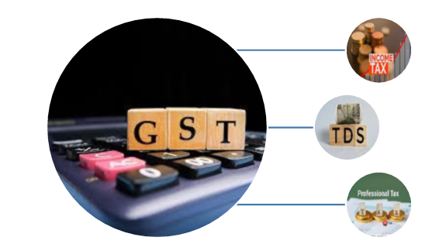

**Transfer Pricing**

**CHAPTER – 03**

**FUNCTIONS/OPERATIONS**

**OF ORGANIZATION**

**INTRODUCTION :**

Accounting, also known as accountancy, is the measurement, processing, and communication of financial and non-financial information about economic entities such as businesses and corporations.

Accounting, which has been called the "language of business”, measures the results of an organization's economic activities and conveys this information to a variety of stakeholders, including investors, creditors, management, and regulators.

Practitioners of accounting are known as accountants. The terms "accounting" and "financial reporting" are often used as synonyms.

Accounting can be divided into several fields including financial accounting, management accounting, tax accounting and cost accounting Financial accounting focuses on the reporting of an organization's financial information, including the preparation of financial statements, to the external users of the information, such as investors, regulators and suppliers.

Management accounting focuses on the measurement, analysis and reporting of information for internal use by management.

The recording of financial transactions, so that summaries of the financials may be presented in financial reports, is known as bookkeeping, of which double-entry bookkeeping is the most common system.

Accounting information systems are designed to support accounting functions and related activities.

**Serving Area of firm:**

**To offer in full range of services to the clients in the following areas:**

a) Audit & Assurance

b) Taxation Advisory

c) Business Management Consultancy

d) Internal Auditing

e) Accounts preparation

1. **Audit & Assurance:**

To provide external audit & assurance service to firm client that is required by different statutory bodies as compulsory for firm clients.

1. **Taxation & advisory:**

In the changing global scenario, the Government of Bangladesh is trying to be self-reliant by collection more revenue from its own sources that is leading to extension of tax net of the country. In the situation , technical advisory service to the clients to minimize tax burden complying all applicable rules and regulation.

1. **Business Management Consultancy:**

Present business environment is getting complicated due to multiple statutory obligations imposed upon by different authority. The entrepreneurs themselves cannot deal all such factors through their in-house capacity. Long experience to guide firm clients in the consultancy on the business management.

1. **Internal Auditing :**

Internal auditing is the appraisal of effectiveness and efficiency of internal control and compliance system of an organization. Through firm services in the field of internal audit, help identify the risks involved in the achievement of the organizational goal.

1. **Accounts preparation :**

Facilitate firm clients by providing professional staff to prepare accounts of an entity in the compliance of all applicable accounting standard and laws of the state.

**Terminologies:-**

**Account**: A record that holds the results of financial transactions related to the entity the account refers to.

**Accounting:** The process of recording, managing, measuring, evaluating and reporting an entity’s financial information

**Accounts Payable:** Accounting definition of amounts that are due from your business to creditors in the short term

**Accounts Receivable:** Amounts that are due to your business from your customers, generally in the short term

**Audit:** The result of an independent professional accountant examining the financial statements to determine fairness and compliance with generally accepted accounting principles (GAAP).

**Balance Sheet:** An important financial statement that lists the total assets and the total liabilities of an entity in an itemized form.

**Current Assets:** The assets of a company that are usually converted to cash, sold, or used in the short term such as cash, accounts receivable, short-term investments and inventory.

**Current Liabilities:** Liabilities that are expected to be paid within one year of the balance sheet date.

**Fixed Assets:** The permanent assets of a company that will not be converted into cash during the next year such as the land , building, equipment and furniture.

**Fixed Cost:** The fixed operating expenses required for the necessities with no relation to the volume of production and sales such as rent, property taxes, and interest.

**General Journal:** (GJ) A book or original entry in a double-entry system that includes all transactions except those in specialized journals such as cash receipts, cash disbursements, and other common transactions.

**General Ledger:** (GL) A book in which financial transactions are posted (in the form of debits and credits) from a journal. It is the primary record from which financial statements are prepared.

**Gross Profit:** The amount by which the net sales exceed the cost of goods sold. Gross Sales: The total recorded sales before deducting any sales discounts or sales returns and allowances.

**Journal:** A book or original entry used in a double-entry bookkeeping system with details of all transactions and the accounts to which they are posted.

**Journal Entry:** A transaction record where debits equal credits.

**Profit and Loss Statement:** Also known as an Income Statement, or P & L. A financial statement that details the revenues and expenses for a specific period of time.

**Trial Balance:** The trial listing of all account balances to check if total debits equal total credits.

**Need of the study:**

**It Helps in Evaluating the Performance of Business**

Your financial records reflect the results of operations as well as the financial position of your small business or corporation. In other words, they help you understand what's going on with your business financially. Not only will clean and up to date records help you keep track of expenses, gross margin, and possible debt, but it will help you compare your current data with the previous accounting records and allocate your budget appropriately.

It Ensures Statutory Compliance Laws and regulations vary from state to state, but proper accounting systems and processes will help you ensure statutory compliance when it comes to your business.

**It Helps to Create Budget and Future Projections.**

Budgeting and future projections can make or break a business, and your financial records will play a crucial role when it comes to it business trends and projections are based on historical financial data to keep your operations profitable.

This financial data is most appropriate when provided by well- structured accounting processes.

**It Helps in Filing Financial Statements.**

Businesses are required to file the financial statements with the Registrar of Companies Listed entities are required to file them with stock exchanges, as well as for direct and indirect tax filing purposes, Needless to say, accounting plays a critical role in all these scenarios

**Details to be filled in company creation**

**1.**

**A. Name**

In this field, we are required to type the name of the company,

for example. XYZ INC.

**Primary mailing details**

* **Mailing name**

In this field, we are required to type the name of the company, for example.

XYZ INC.

* **Address**

In this data field, we required to enter the address of the company.

* **Company**

Here we are required to select the country from the list in which the business Operates.

* **State**

In this data field , we have to select the state in which we would comply with statutory laws

* **Pin code**

Pin code of the location where the office exists.

1. **Contract details**

* **Phone no**

Enter the Company contract number which we would like to display on Invoices

* **Mobile no**

Enter the Contract number of Managing Person to whom any queries related to Invoicing or Delivery of product, complaint in the product could be reached to

* **Fax no**

Enter the Fax number to which any confirmation statements ,ledger copies etc.;could be sent and received

* **E-mail**

Enter the company’s email address to which any product inquiry and other communications could be made.

* **Website**

Enter the company’s web address if any

**C. Books and financial year details**

* **Financial year begins from**

In this data field , you have to type the financial year in which you want to create a company. Suppose you may be starting company on December 01 2018. You should enter the financial year from as 01.04.2018.

* **Book beginning from**

In this data field, you have to type the financial year in which you want to create a company. Suppose you may be starting company on December 01 2018.youshould enter the financial year as 01.04.2018.

* Starting in the middle of the financial year.
* Companies which are migrating from Manual accounting to Tally ERP 9 in the middle of the financial year.

**2. GST**

GST or Goods and services tax is the value-added tax levied upon the goods and services sold for domestic consumption. The tax charged at every stage of the production process is refunded to all parties in the production chain except the end customer/consumer.

**What are the types of GST?**

GST has brought a reform in taxation in India . Various types of indirect taxes replaced by GST is categorized under four categorized . GST is an indirect tax (or consumption tax) used in India on the supply of goods and services. Goods and services are divided into five tax slabs for collection of tax-0%,5%.12%,18%and 28%.From july 1,2017,GST came up as single taxation system in India and replaced all the indirect taxes in the country . Some of the indirect taxes that were abolished were Central Excise Duty, VAT, Entry Tax and Octroi.

**Different forms of GST collected by government are :**

**State GST (SGST):** It is collected by the government. SGST is a state Goods and services tax. It is applicable to suppliers who dealing within the state. Taxes that are collected will be shared with the state authority body.

**Central GST (CGST):** It is collected by Central Government. CGST is a Central Goods and services tax. It is applicable to suppliers dealing within the state . Taxes that are collected will be shared with the central authority body.

**Integrated GST (IGST) :** It is collected by Central Government for inter-state transactions and imports. IGST stands for an Integrated Goods and services Tax. It is applicable to suppliers who dealing with interstate business and imports transactions .Taxes which are collected will be shared to central and state authority body.

**Union Territory GST (UTGST) :** It is collected by Union Territory Government .

Simple formula ;

* GST Amount = (Original Cost * GST Rate Percentage )/100
* Net Price = Original Cost + GST Amount

Example

If a goods or services is sold at Rs.1,000 and GST rate applicable is 18%

Then the net price calculated will be =1,000+(1,000*(18/100)=1,000+180+Rs.1,180.

**3. Bank Statement**

**Process No 1-**

Create a ledger under bank accounts and then save the same .

**Process No 2-**

Go to the accounting vouchers menu and then we need to select what kind of voucher do we need to pass using the bank account. One can use 2 voucher type to pass a bank Entry in Tally ERP 9

**Payment –**

To make payment entry . Debit the expenses Ledger ( for cash transactions )/Party Ledger (for non – cash transactions) and Credit the Bank . The short cut key to Select Payment Voucher is F5.

**Receipt-**

To make receipt entry. Debit the Bank ledger and Credit the Party Ledger (for cash transactions)/Income ledger (for non- cash transactions).The shortcut key to Select receipts Voucher is F6.

**Contra-**

Use for the only cash transactions . Debit/ Credit Bank/Cash. The Short cut key to Select Contra voucher is F4.

**4. ENTRY OF BANK STATEMENT IN TALLY**

Every company has its own bank account .Large amounts of transactions such payments from the creditors and payment to the debtors take place through bank. So it is necessary to record this transactions.

Open tally--------select the company-------select balance sheet-------select current assets--------select the bank A/c ---------and select respective vouchers for respective transactions……

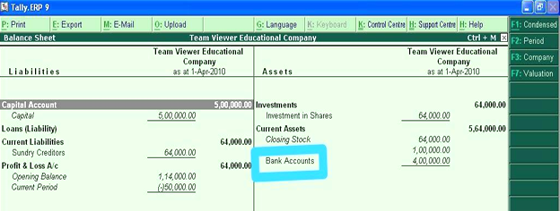

Cash Deposit Bank entry

Voucher type : Contra Voucher Shortcut Key – F4

Entry: Bank A/c (Dr)

To Cash (Cr)

Cash withdrawal

Entry : Cash A/c (Dr)

To Bank A/c (Cr)

Bank entry for cheque Issued or given to a supplier

Entry : Supplier A/c (Dr)

To Bank A/c (Cr)

Payments

Entry: Dr the Expenses

Cr the bank

Receipts

Entry : Dr the Bank

Cr The Party

**5. MS EXCEL**

For CA professionals, learning about the Microsoft Excel spread sheet software is necessary.

Excel is designed for recording and analysing numbers/data, and mastering it can help CAs in a number of ways. They should know how to use Excel for analytics, accounting, financial management , calculating taxes, formulas ,and other purposes.

Auditing formulas

You no longer have to be a calculus which to get the most out of excel formulas. The Formula Auditing toolbar gives you quick and dirty access to an error checking function that works especially well on large and complicated worksheets .Even if you are working with a smaller worksheet ,you can still make the process of creating and auditing your formals speed along much more quickly.

The Formula Tab is where you will find the Formula Auditing toolbar. From here , you can choose from a number of options, including formula execution, tracing formula precedents, hunting down errors and locating dependent cells.

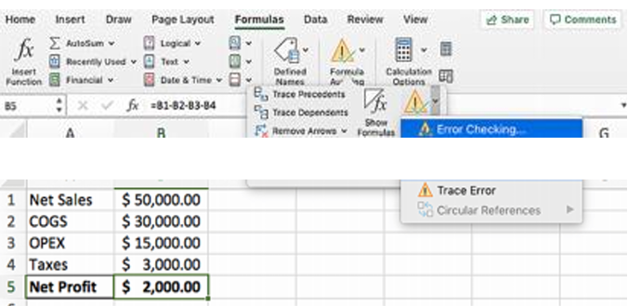

**Creating a company**

To use Tally, you need to ‘create a company.’ In the menu section, select ‘Create a

company.’ This will take you to a screen wherein you need to fill in the details

about your company.

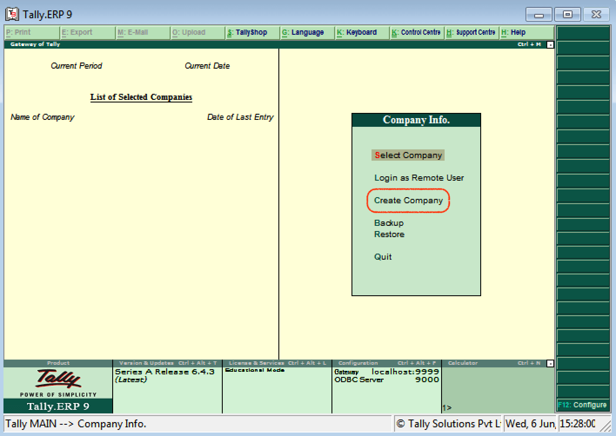

• Enter company name, as mentioned in the banking records. Add company address,

telephone number, and information on statutory compliance.

• Choose ‘Accounts info’ if you are just using Tally to manage your accounts.

• Choose ‘Accounts with inventory’ for the menu if you are using Tally for inventory

management as well.

• Choose your preferred currency.

• Enter the start of your financial year, plus the start date for the books.

• Also, don’t forget to turn on the ‘Auto backup.’ This will ensure you have a copy of

the details for future needs.

**Creating a Ledger**

A ledger helps you to record all the transactions of different accounts. You can create a

separate ledger for different accounts that you do business with. This will provide more

clarity if you need information on transactions of a particular account in the future.

There are two types of ledgers here; ‘Cash’ and ‘Profit & Loss Account’.

To create a new ledger;

**Step 1 –** From the Gateway menu, select ‘Accounts info.’

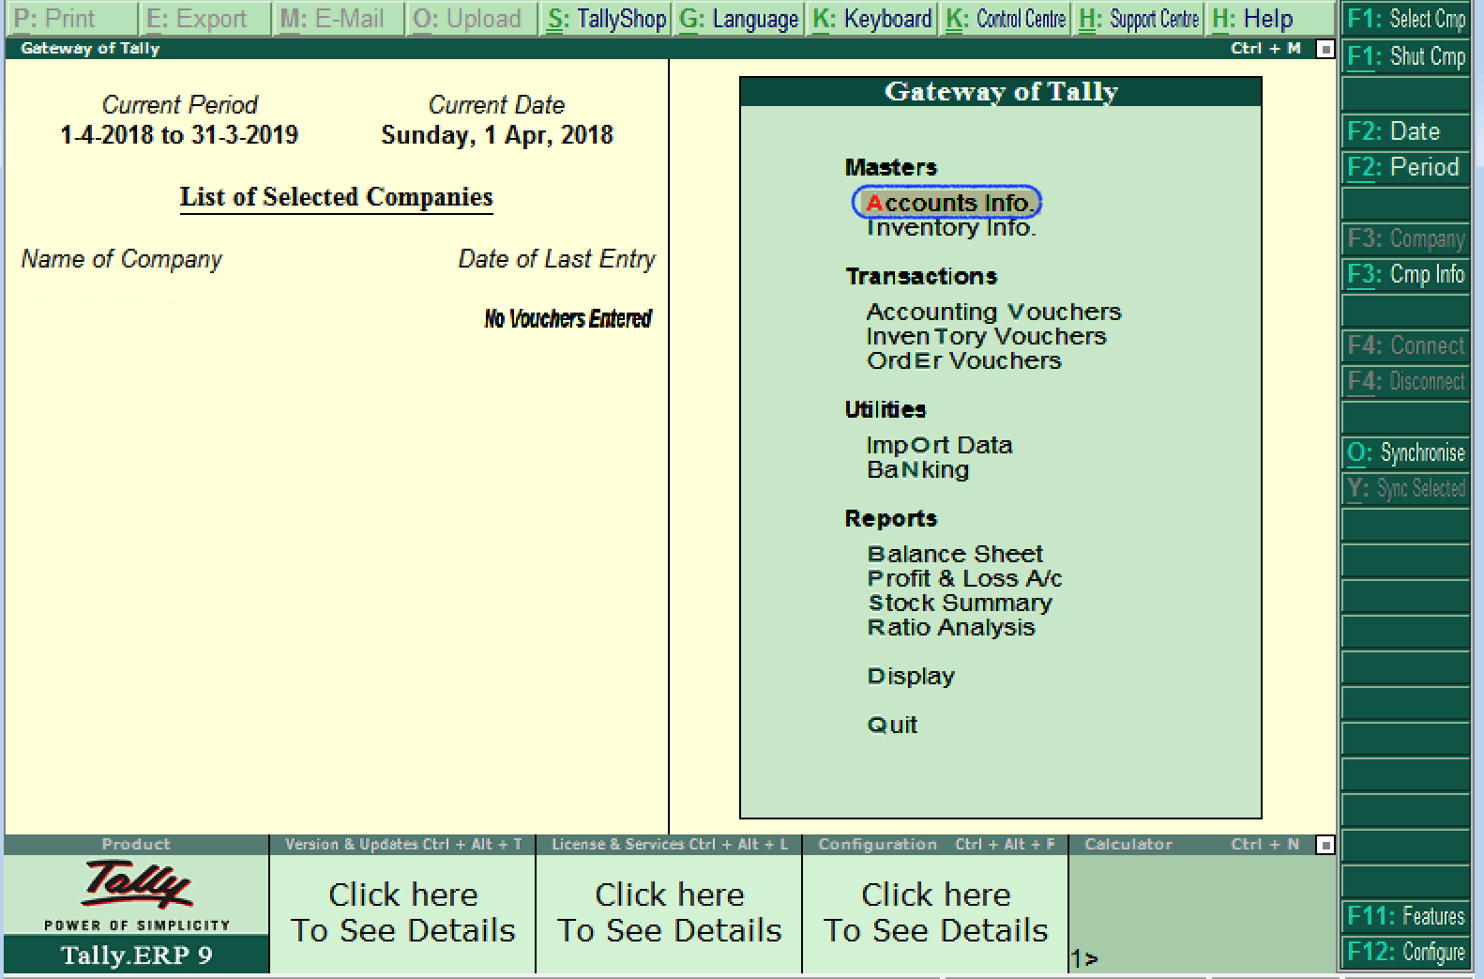

**Step 2** – Next, click on ‘Ledgers’ followed by ‘Create.’ Here, you can create a single ledger or multiple ledgers as per your needs.

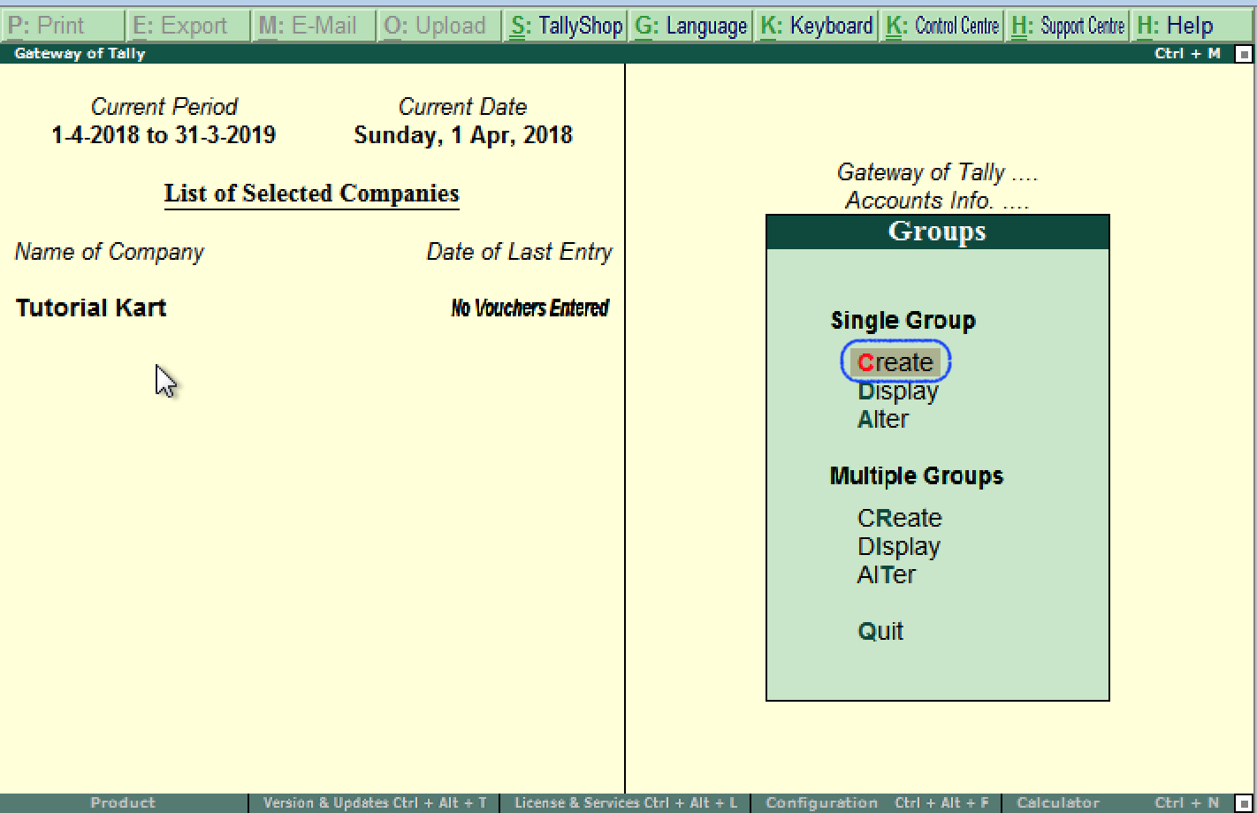

**Step 3** – After creating a ledger, you also need to choose which group a particular ledger will be assigned to. You can select a group from the given ‘List of Groups.’

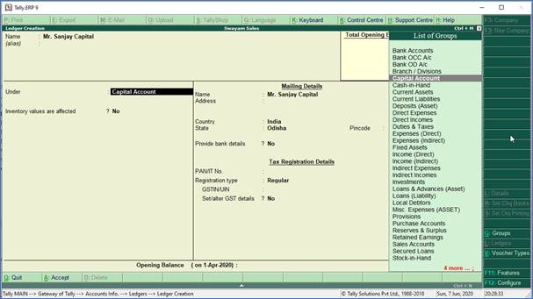

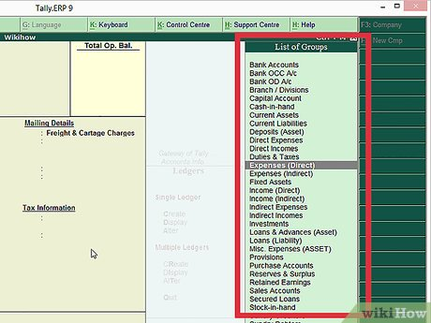

**Step 4** – Also, for easy identification, always enter a name for your ledger so you know what it contains.

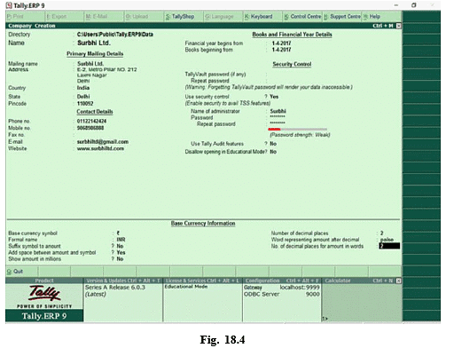

**Step 5** – Lastly, enter the opening balance. For a bank account, the opening balance in the ledger would be the current amount in your account. For an amount owed to you by a client or a contractor, the starting amount would be what they owe you. For example; ₹10,000/-

**Creating a Voucher**

One of the perks of using Tally.ERP 9 is that it comes with several pre-configured types of

vouchers. A voucher is a document that records the details of a financial transaction and is

used by businesses for multiple purposes such as sales, deposits, everyday expenses, etc.

**To create a voucher, you need to;**

**Step 1** – From the Gateway menu, choose “Accounting Vouchers.

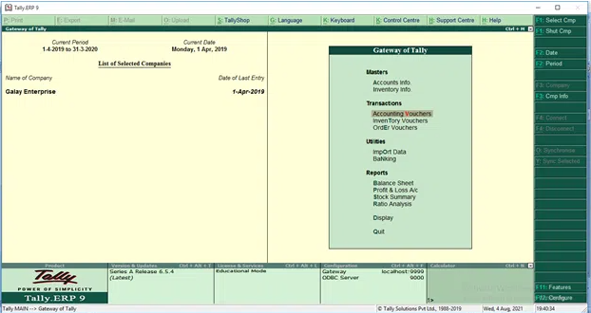

**Step 2:-**

Choose the voucher you want to create. On the right menu, you will see a list of available vouchers you can create. Select the one that meets your needs best.

• Contra Voucher (F4) - Contra vouchers are for when money is deposited or

withdrawn for the bank, or transferred between two accounts in the same company.

• Payment Voucher (F5) - This voucher is for payments made by the business.

• Receipt Voucher (F6) - This voucher is for any income made by the company

(sales, rent, interest, etc.)

• Journal Voucher (F7) - Transactions that don't relate to sales, purchases,

cash, or other income. Mostly used for adjustments and opening and closing balances.

• Sales Voucher/Invoice (F8) - This voucher is for all sales made by the company.

• Purchase Voucher (F9) - This is for the purchase of assets by the company.

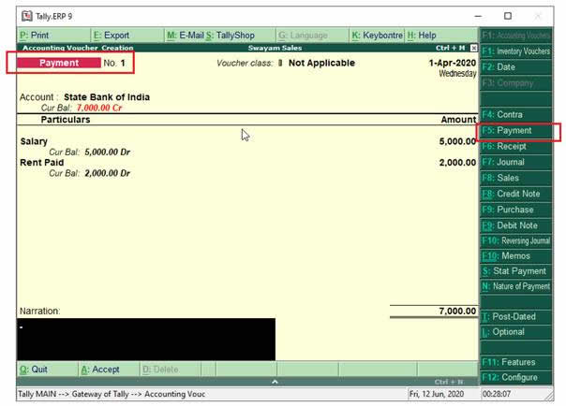

**Step 3:-**

Enter in the required information. The information needed to complete the voucher will

vary depending on the type of voucher you want to create. You will typically need

to determine which ledger the voucher will be attached to, as well as enter the

date and names of any involved parties.

If you are entering products being purchased or sold, Tally will automatically calculate

totals based on the quantity you select

**Debit Note and Credit Note in Tally ERP9**

In simple words about Debit and Credit notes, when there are purchase returns and

sales returns in any business, debit note used for purchase returns and credit note

used sales returns.

**Debit Note in Tally ERP9**

This note will use for purchase returns, it is issued by a buyer to a seller debiting

to his account and requesting for credit note.

How to Activate Debit Note and Credit Note in Tally ERP9

Path: Gateway of Tally -> F11 Features -> Accounting Features

Use debit and credit notes: Yes

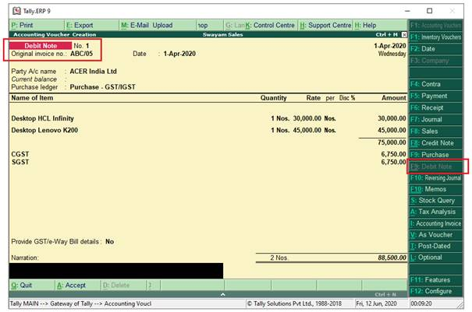

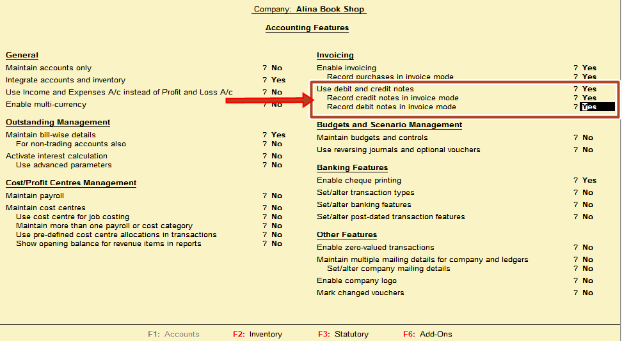

**Credit Note in Tally ERP9**

This note will use for sales returns, it is issued by a seller to buyer in different situations informing that his account is credited.

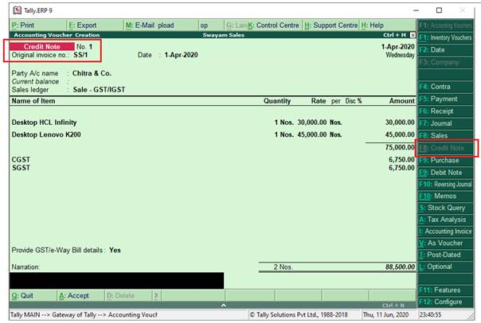

**Theoretical Overview Of Auditing:-**

An auditor is someone who prepares and examines financial records. They ensure that

financial records are accurate and that taxes are paid properly and on time. They assess

financial operations and work to help ensure that an organization runs efficiently.

In this area, we were done different type of work such as matches the balances of

Transactions from software information with our tally voucher entries information. We check

different financial records of companies any analyze that and identify the mistakes then give

some suggestions to them.

An audit is a systematic and independent examination of books, accounts, statutory records,

documents and vouchers of an organization to ascertain how far the financial statements as

well as non-financial disclosures present a true and fair view of the concern. It also attempts

to ensure that the books of accounts are properly maintained by the concern as required by

law.

Auditing has become such a ubiquitous phenomenon in the corporate and the public sector

that academics started identifying an Audit Society. The auditor perceives and recognizes

the prepositions before them for examination, obtains evidence, evaluates the same and

formulates an opinion on the basis of his judgement which is communicated through

their audit report.

Any subject matter may be audited. Auditing is a safeguard measure since ancient times.

Audits provide third party assurance to various stakeholders that the subject matter is free

from material that the subject matter is free from material misstatement. The term is

most frequently applied to a legal person. Other areas which are commonly audited include:

secretarial and compliance audit, internal controls, quality management, project

management , water management and energy conversion.

**OVERVIEW OF VOUCHING**

Vouching is a technical term which refers to the inspection of documentary evidence supporting and substantiating a transaction, by an auditor.

It is the practice followed in an audit, with the objective of establishing the authenticity of the transactions recorded in the primary books of account.

It essentially consists of verifying a transaction recorded in the books of account with the relevant documentary and the authority on the basis of which the entry has been made; also confirming that the authority on the basis of which the entry has been made; also confirming that the amount mentioned in the voucher has been posted to an appropriate.

Accounts which would disclose the nature of the transaction on its inclusion in the final statements in account.

Vouching do not include valuation. Vouching can be described as the essence or backbone of auditing.

**LIMITATIONS**

* Duration of the internship was quite small.
* At times the data available for study can be too large, which makes it a time

consuming tasks

* Change in government policies and procedures may act as threat for company.

* A small change in focus of large competitor might wipe out any market position

achieved.

* They have a small staff with shallow skills base in many areas.
* Less number of staff members.
* Developments in technology change this market beyond SRINATH L &CO. Ability to adopt.
* SRINATH L & CO . Has many competitors. Under certain circumstances these competitors may act as a major threat for the organisation.

**CHAPTER – 04**

**LEARNING AND OUTCOMES**

* I developed some professional skills like communication, technical skills, task management etc.
* Knowledge about accounting works in tally, how to use tally software. Creation of ledger and posting entries of bank statement in tally.
* Making entries of purchase and sales bill , splitting company data and creating company, posting of opening balance in tally.
* Integrate theory and practice and developing work habits, learn things apart and more than theoretical knowledge.
* Getting practical experience in a real life, assess interests and abilities in this field.
* Adapting quickly to changing environments , gets exposure to do a work in an organisation and also came to know about organisational behaviour ethical rules and regulations.
* Analyse the business situation , establish high standard in professionalism.
* Learn book keeping practices of different companies.
* Make quick decision in real situation.
* Promote my personal knowledge and professional preparation for future.
* Plan for the future of oneself and learn how to adjust in an organisation.
* Responsibility to the profession. Knowledge about auditing and taxation.
* I learn the vouching , maintain books of account, Journals entries, voucher entry etc.
* Describe the primary books account and register like: cash book, bank book, purchase registers, sales register, journal register, debit note register, general ledger etc.
* Submit all documents to companies.
* Verify that all outgoing checks were properly signed, accounted for and posted to the correct accounts.
* Discuss the principles and legal rules applying to dealing and other matters.
* Review all financial statements.

**FINDINGS**

• The internship at Srinath .L Auditor & co. Was my first experience where I get to learn about the services provided by CA firms.

• Initially I know about the working environment and procedures to be followed.

• Then here I get to find about the financing strategy and the hard work to be done and adopting new strategy to get work done. .

• The work is done by in-depth analysis of the study about the work and take the decisions according to it.

• From these I find out that the firm operated to get work done follows the process and government guidelines and to approach the clients and collect the data.

• The company uses Tall software is limited to accounts use only.

• But switching to customized software would give more flexibility and productivity. Customized software needs skilled and trained professional to operate

**SUGGESTIONS**

• Main server system should be technically fine so that it won’t create a barrier for Other systems.

• Rotational work should be distributed among the employees so that catch & every employee must be aware about everything.

• Hardware systems & other devices should be of good quality & quantity so that it won’t create a lack of electronic equipments i.e (Monitor, keyboard, mouse, epu LAN connection, printer)

• They have good opportunity to introduce the ISO standards training program which no other firm is giving to customer.

• SRINATH L & CO strongly needs to improve its network firms so as to be counted among one of the extensively know firms. The partner needs to make the best use of their goodwill to bring more client age and reputation to firm. They need to offer the audit services at most economical cost with the assured quality services to retain and expand clients.

• The company has mostly professional educated human resources, which are the biggest threat for their competitors.

• The local economy continues to be strong and we believe our typical clients will continue to flourish. With its competitors has an edge to make an accurate and error free report.

**CONSULTIONS**

I was a finance intern in Srinath L auditor & Co , and during mu internship I got handful of knowledge on preparing tally, preparing bank statements, statutory audits, filing GST and income tax returns. This helped me to understand more on theoretical knowledge of bookkeeping practices of different companies and it helped me to relate the concepts I had learnt previously and also got knowledge about the opportunities and threats that will be faced while entering into organization, got exposure to do work in an organisation and also understood about rules and regulations to be followed in an organization.

During my internship I was able to gain knowledge regarding some of the important things like income tax, goods and services and the different tax slabs. Customer behaviour was understood more deeply as I progressed through the internship because I was given opportunity to interact with the clients directly. Team spirit evolving in the organisation helped to get work done in a faster way.

I found little difficulty during first few days of my intern but then when I was used with the terminologies, then I had a better understanding of the work. Getting used to new words helped me to gain knowledge about the business in a practical way.

Apart from the knowledge gained from the internship it enables me to gain first-hand information relating to the functioning aspects of the firm. The internship added more confidence to my professional approach and to build a strong positive attitude in myself. The important things that I learned and followed during my intern are time management and self-motivation.

I believe that this internship have given me value addition which in turn will help my studies as well as my career in the corporate world.

**CONTRIBUTION DURING INTERNSHIP**

**Learning:-**

I have tried my best to enhance my abilities and apply the knowledge that I gained during the studies.

Studies computerized accounting in tally software .

**Different task that I performed during my internship:**

* Vouching
* Preparing books of accounts in tally
* Voucher

**Entry Software used during internship:**

➤ Microsoft world, Microsoft excel

➤ Tally software

**REFERENCE**

W.W.W.WIKIPEDIA.COM

w.w.w.google.com

https ://www.vedantu.com/commerce/computerized-accounting system

<https://www.scribd.com>

<https://gscen.shikshamandal.org>

<https://dspace.daffodilvarsity.edu.bd>

<https://www.slideshare.net>

**1th WEEK WORK REPORT**

**05-02-2025 TO 06-03-2025**

|  |  |  |
| --- | --- | --- |
| **NO.DAY** | **DATE** | **WORK UNDERTAKEN** |
| 1 | 05-02-2025 | Introduction about the CA firm |
| 2 | 06-02-2025 | Introduced about the working of the firm and services offered by them. |
| 3 | 07-02-2025 | Learning about the product of the company |
| 4 | 08-02-2025 | **2nd Saturday Holiday** |
| 5 | 09-02-2025 | **Sunday** |
| 6 | 10-02-2025 | Explained the basic accounting practices |

**2nd WEEK WORK REPORT**

**05-02-2025 TO 06-03-2025**

|  |  |  |
| --- | --- | --- |
| **NO.DAY** | **DATE** | **WORK UNDERTAKEN** |
| 7 | 11-02-2025 | Started to do report on Auditing |
| 8 | 12-02-2025 | Did some research on company |
| 9 | 13-02-2025 | Understanding the structure and work culture of the company |
| 10 | 14-02-2025 | Studying about the customers response about the company serving |
| 11 | 15-02-2025 | Banking Statement |
| 12 | 16-02-2025 | **Sunday** |
| 13 | 17-02-2025 | Study of documentation of clients. |

**3rd WEEK WORK REPORT**

**05-02-2025 TO 06-02-2025**

|  |  |  |
| --- | --- | --- |
| **NO.DAY** | **DATE** | **WORK UNDERTAKEN** |
| 14 | 18-02-2025 | Date analysis of various company |
| 15 | 19-02-2025 | Checking of missing balance amount. |
| 16 | 20-02-2025 | Manager guiding what I have to do |
| 17 | 21-02-2025 | Introduction to Tally ERP9 |
| 18 | 22-02-2025 | Creating of Journal |
| 19 | 23-02-2025 | **Sunday** |
| 20 | 24-02-2025 | Creating of Ledger |

**4th WEEK WORK REPORT**

**05-02-2025 TO 06-02-2025**

|  |  |  |
| --- | --- | --- |
| **NO.DAY** | **DATE** | **WORK UNDERTAKEN** |
| 21 | 25-02-2025 | Creating of Voucher |
| 22 | 26-02-2025 | **Maha Shivaratri Holiday** |
| 23 | 27-02-2025 | Banking Statements |
| 24 | 28-03-2025 | Banking Statements |
| 25 | 01-03-2025 | Banking Statements |
| 26 | 02-03-2025 | **Sunday** |
| 27 | 03-03-2025 | Entry invoice bills |

**5th WEEK WORK REPORT**

**05-02-2025 TO 06-03-2025**

|  |  |  |
| --- | --- | --- |
| **NO.DAY** | **DATE** | **WORK UNDERTAKEN** |
| 28 | 04-03-2025 | Banking Statements |
| 29 | 05-03-2025 | Entry invoice bills |
| 30 | 06-03-2025 | Checking Balance sheet |